FLIGHT 93 NATIONAL MEMORIAL
“A COMMON FIELD ONE DAY… A FIELD OF HONOR FOREVER.”

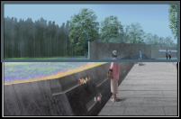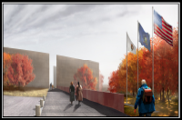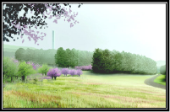

Phase 1 Phase 2 Phase 3
Sacred Ground Entry Portal Tower of Voices
Field of Honor 40 Memorial Groves Allee
Western Overlook
Visitors Center

COMMITMENT OF SUPPORT
- I AM HONORED TO BECOME “ONE OF A MILLION FOR THE 40 OF FLIGHT 93” AND PLEDGE MY SUPPORT TO THE FLIGHT 93 NATIONAL MEMORIAL CAMPAIGN WITH A COMMITMENT OF $__________________.

- CHECK ENCLOSED

- PLEASE CHARGE MY VISA ______ OR MASTER CARD ______

NAME: _________________________________________________________
NUMBER: _________________________________ EXP: _________________
- INSTALLMENTS OF $__________ PAYABLE:
- MONTHLY
- QUARTERLY
- ANNUALLY

PLEASE CONTACT ME ABOUT MAKING A GIFT OF STOCK, BEQUEST, OR OTHER PLANNED GIFT.
NAME: _________________________________________________________________
ADDRESS: ______________________________________________________________
PHONE NUMBER: __________________ EMAIL: ___________________________

SIGNATURE: __________________________________ DATE: _____________

All contributions to the Flight 93 National Memorial Campaign c/o the National Park Foundation are tax deductible to the extent allowed by law. NPF is a 501(c) (3) not for profit organization Checks may be made payable to: Flight 93 National Memorial, c/o National Park Foundation, 1201 Eye Street, NW, Suite 550B, Washington, D.C. 20005 phone202.354.6488 email: flight93memorial@nationalparks.org

